Fop Lab Home Task 3
Name: Hafiz Mufassir Amjad
CMS ID: 456049
Section: B

TASK 1
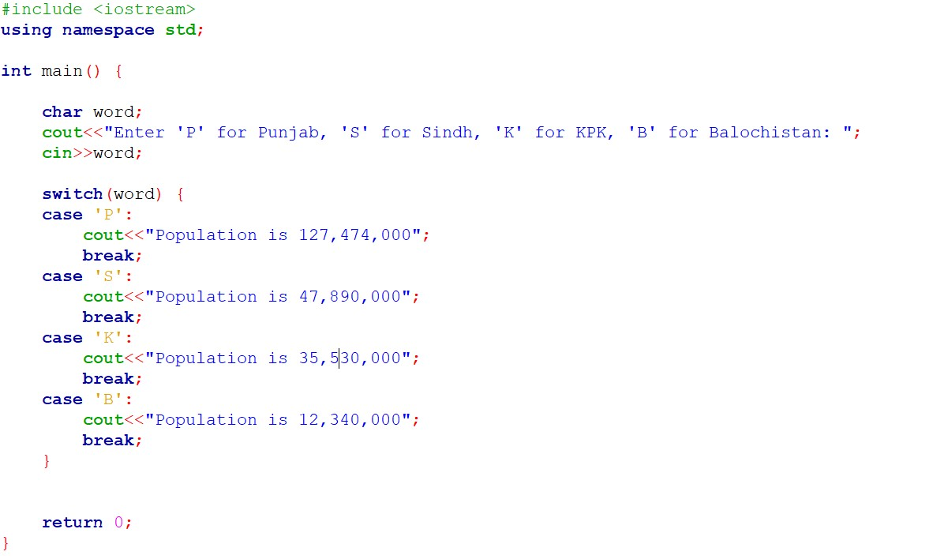
Output
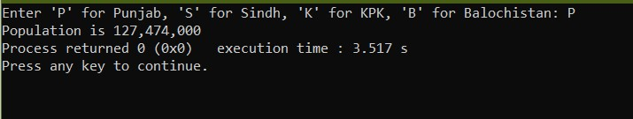
Explanation
This code takes a character from the user according to the specific province and then outputs the population of that province.

TASK 2
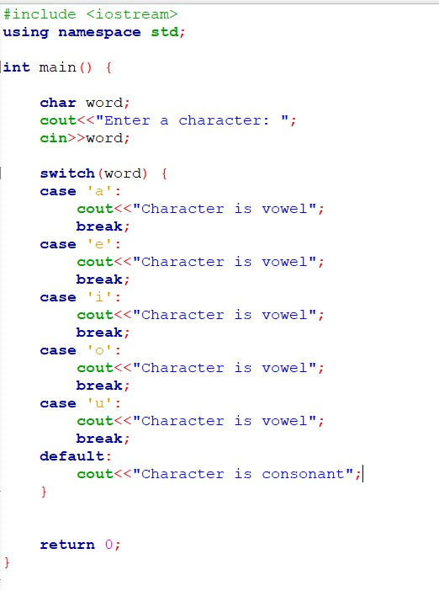
Output
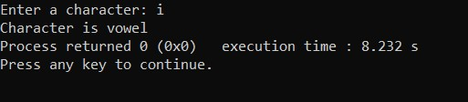
Explanation
This code takes a character as input from the user and by using switch case statement, it determines whether the given character is a Vowel or a Consonant.

TASK 3
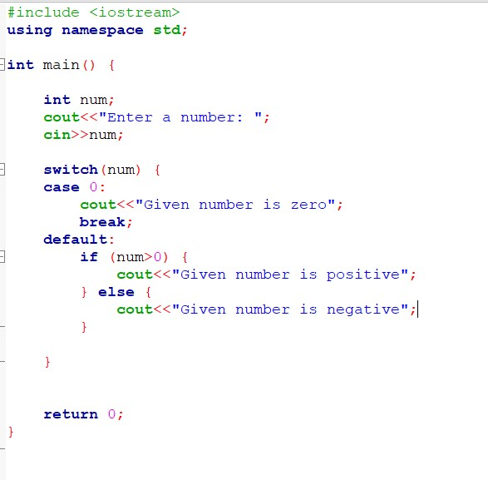
Output
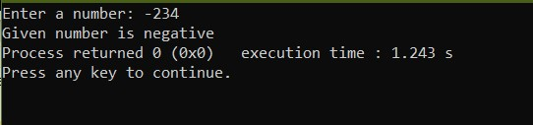
Explanation
This code takes a number from the user and by using switch case and IF statement, it determines whether the number is positive, negative or zero.

TASK 4
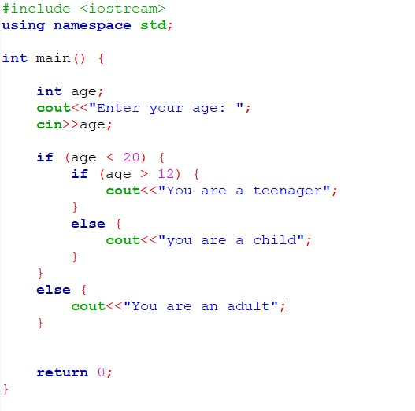
Output
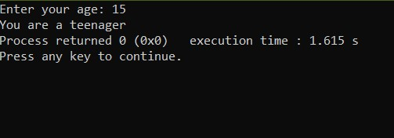
Explanation
This code asks the user for his/her age and then by using nested if-else statements, it determines whether the user is a child, teenager or an adult.

TASK 5
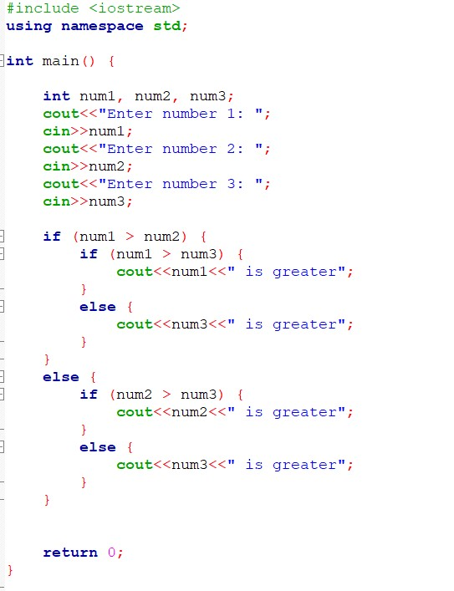
Output
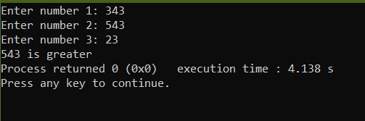
Explanation
This code takes three integers as input and by using nested if-else statements, it determines the highest number between those 3 numbers.
TASK 6
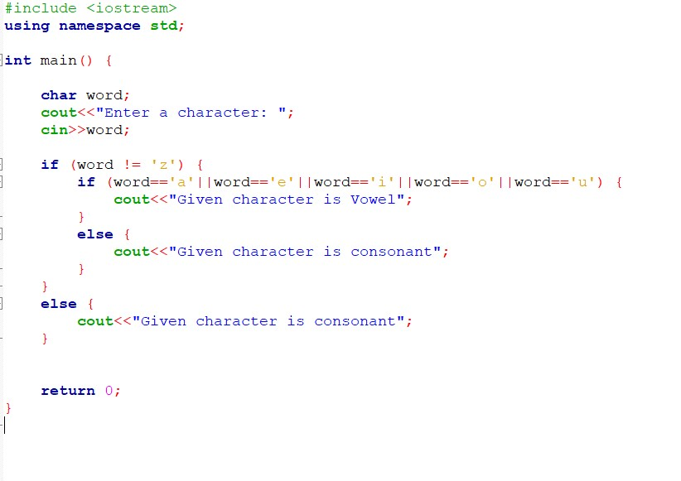
Output
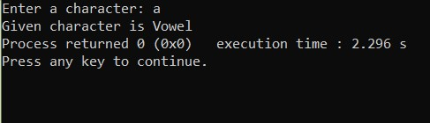
Explanation
By using nested if-else statements, this code determines whether a given character is a Vowel or a Consonant. It takes the character as an input from the user.

